**Assignment: Day- 1**

Name: Soumyadip Ghosh

Stream: CSE

Section: A

Roll Number: 1951007

Assignment -1

Creating a new Project:

* Go to File -> New -> Project

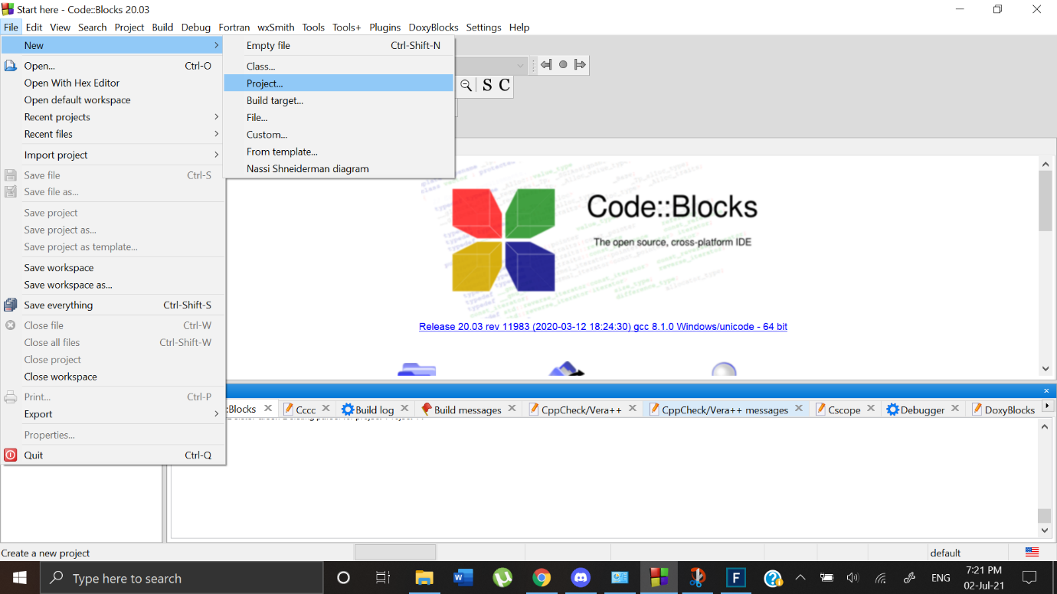 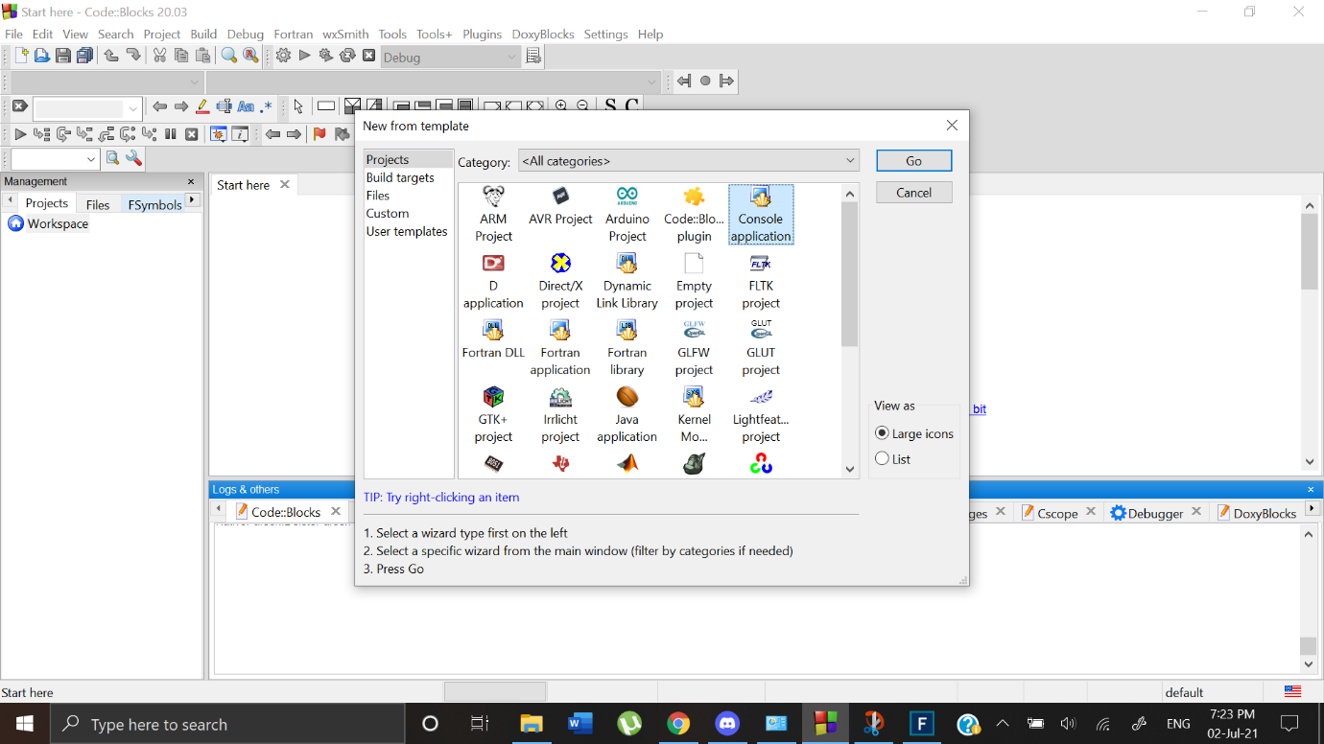

* Select Console Application and then click Go
* Select C application and then click Next

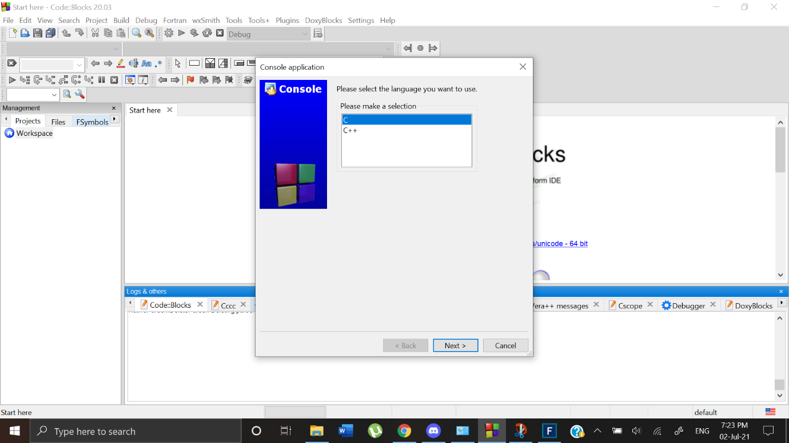

* Specify the path and assign a name to the project

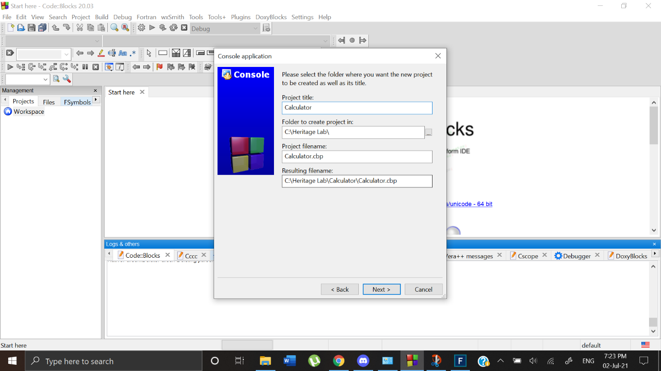

* Then click on Finish

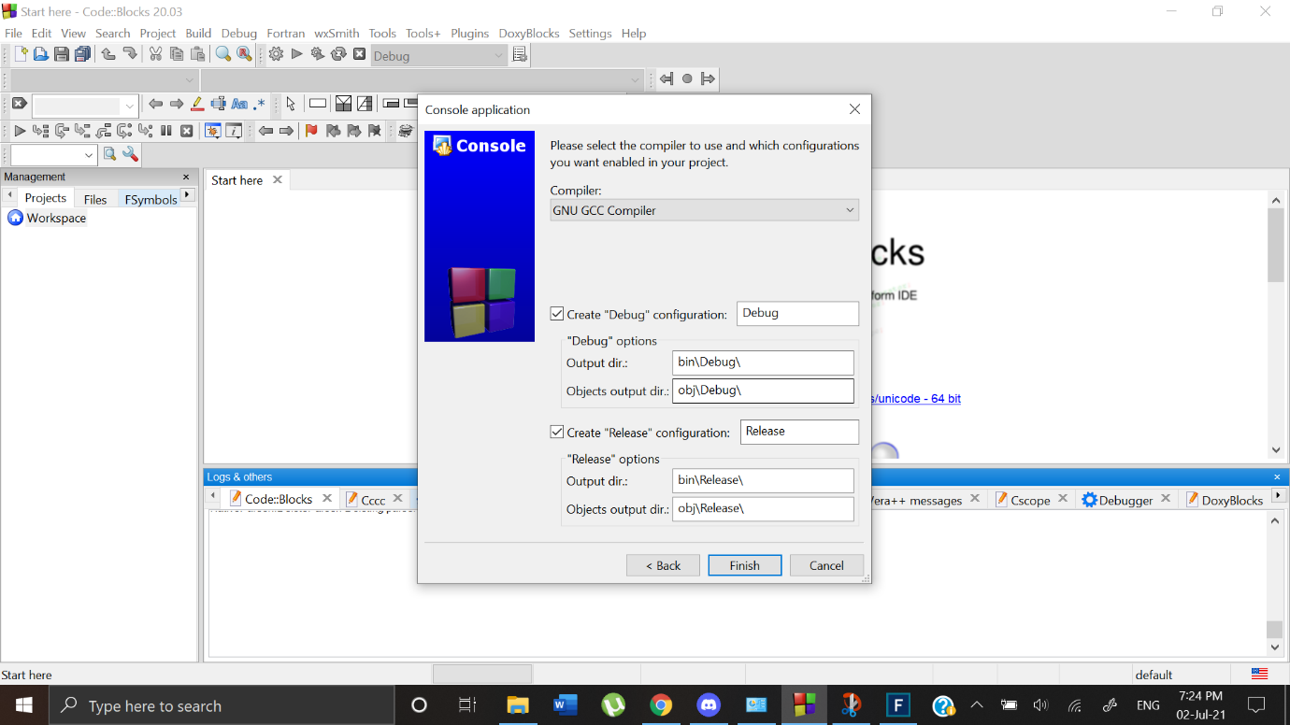

New workspace will be created with main.c. We need to divide the functions into various files for modularity.

Method 1 (Adding files within Codeblocks):

* Create New File

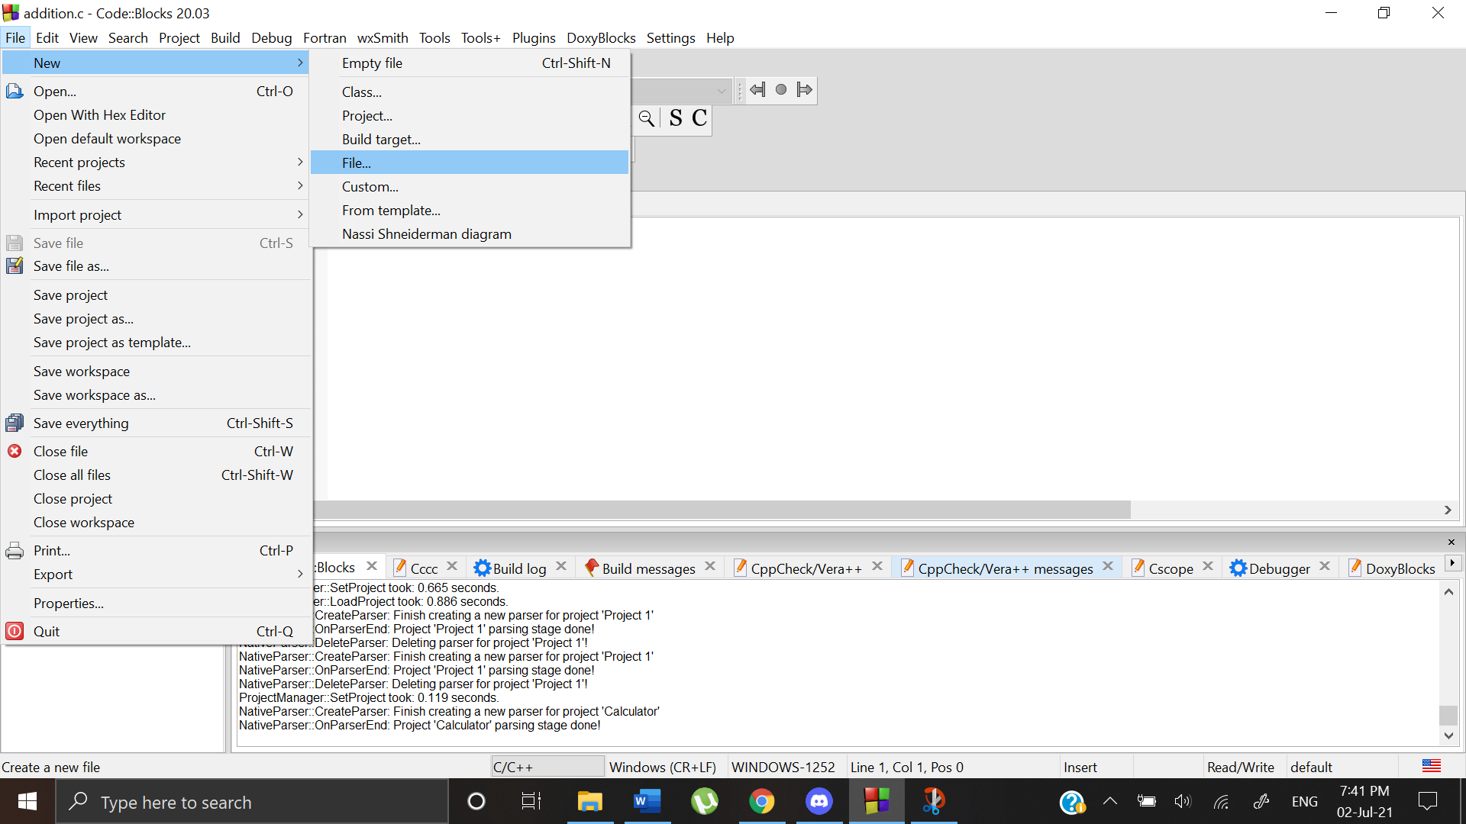

* Select C source

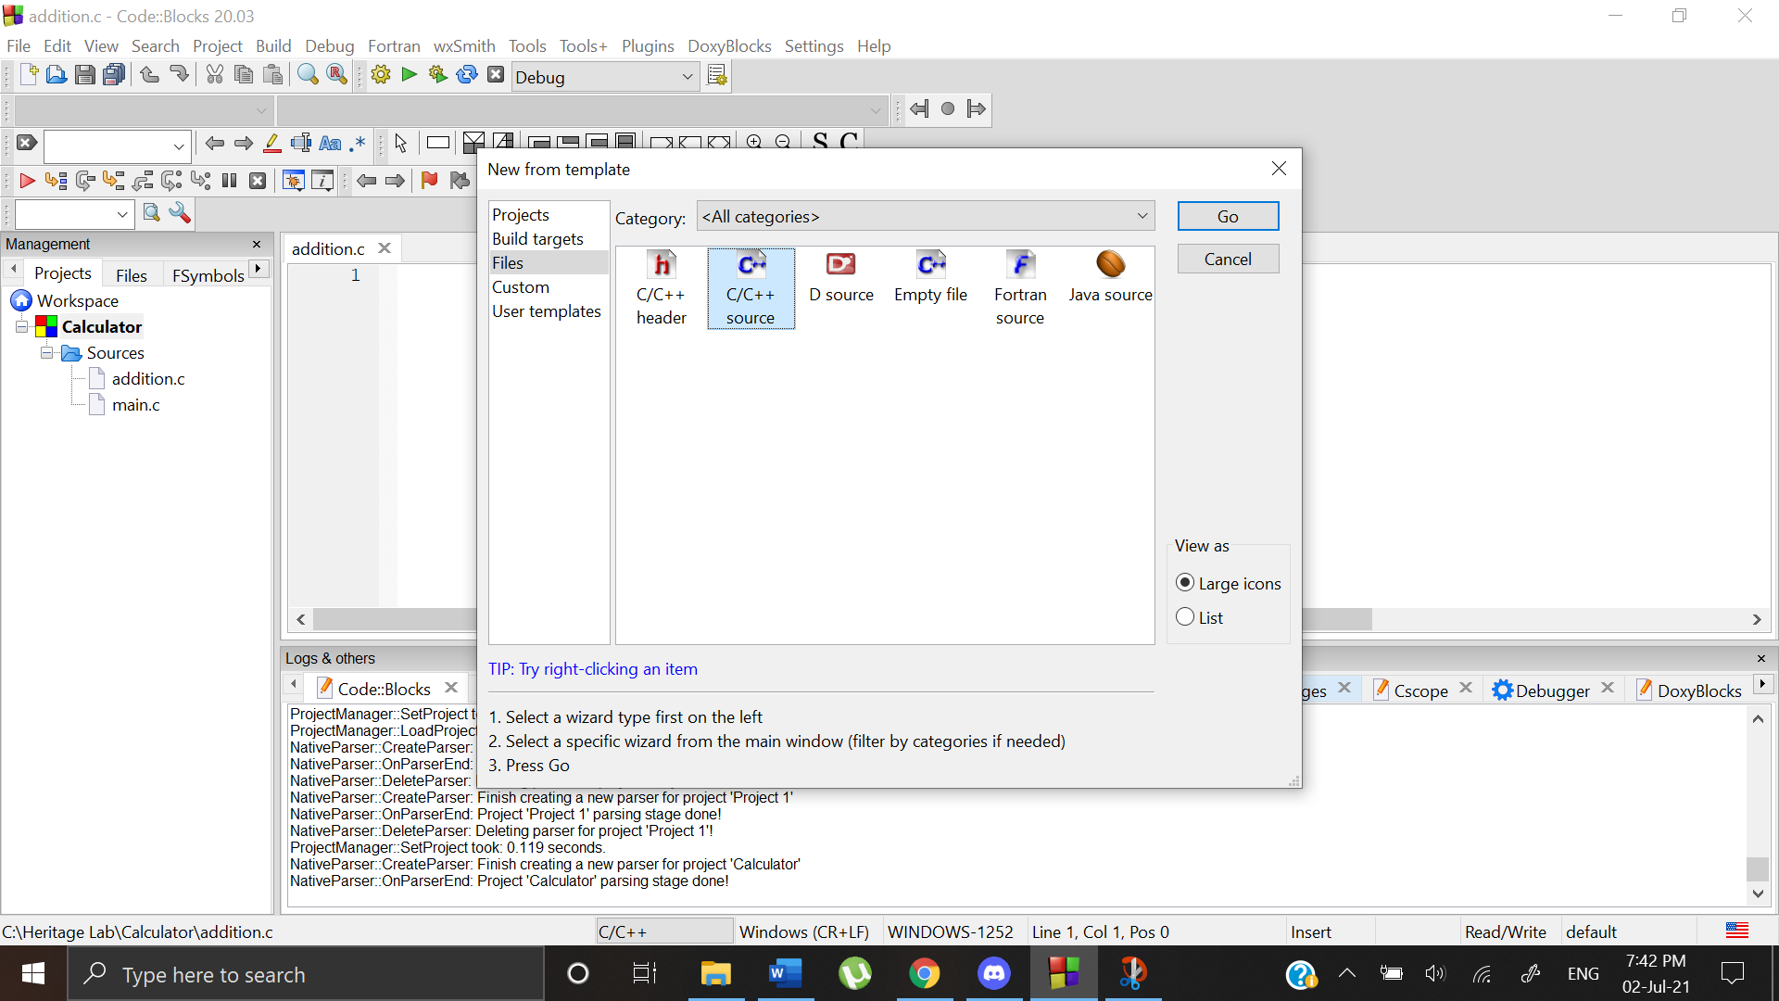

* Select C

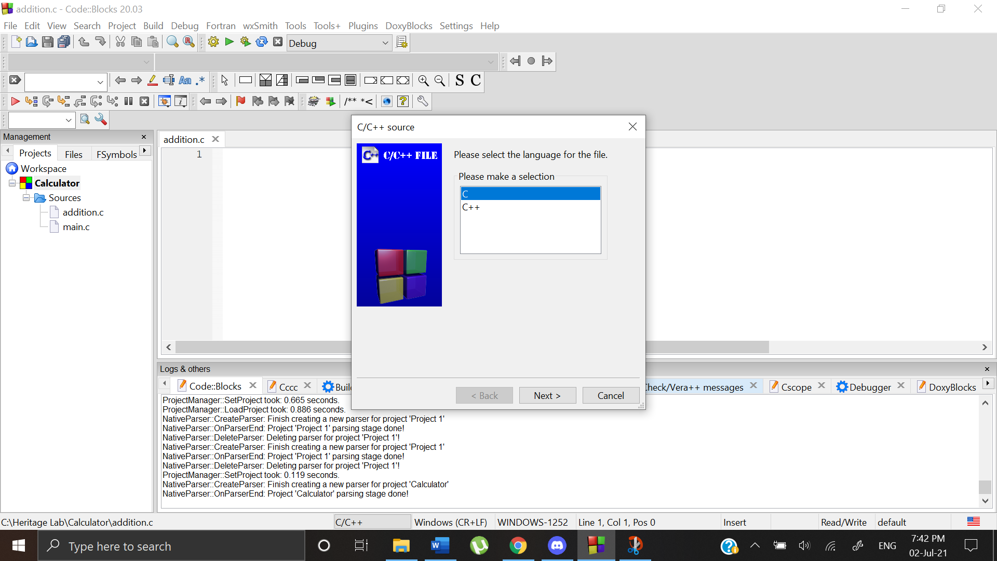

* Specify file name and path

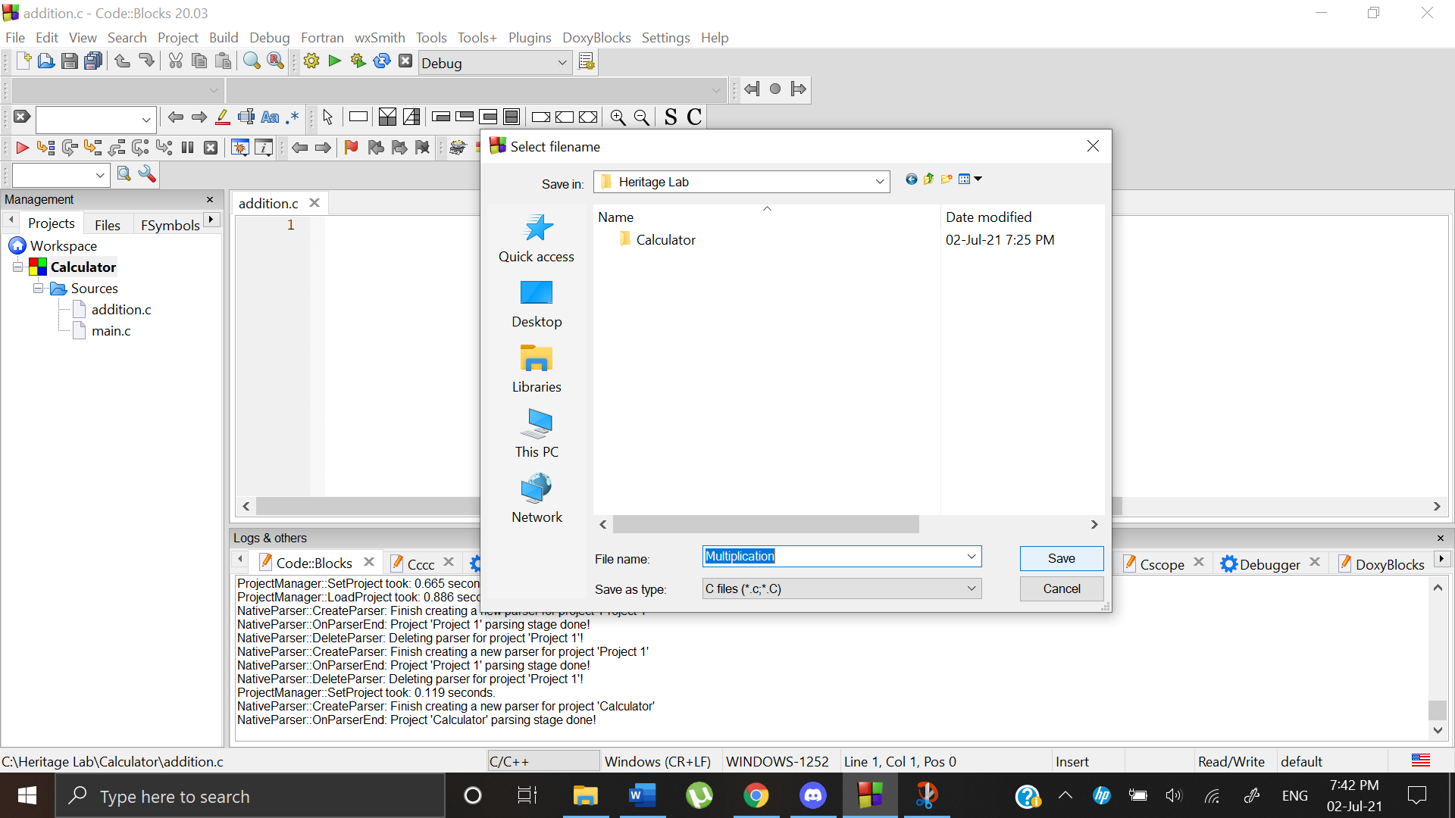

* After this new file is created. To add it to the project we right click on Project Name and then select Add files and then choose the file from the specified location

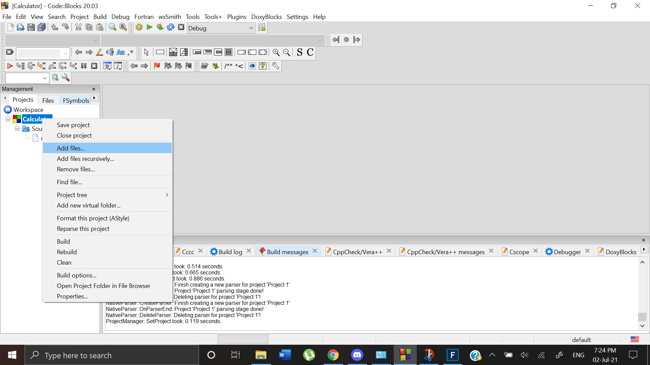

The files are added to project

Method 2 (Adding files outside Code Blocks)

Create a Notepad File and save it with C extension at any desired location.

Follow the above steps to add the files

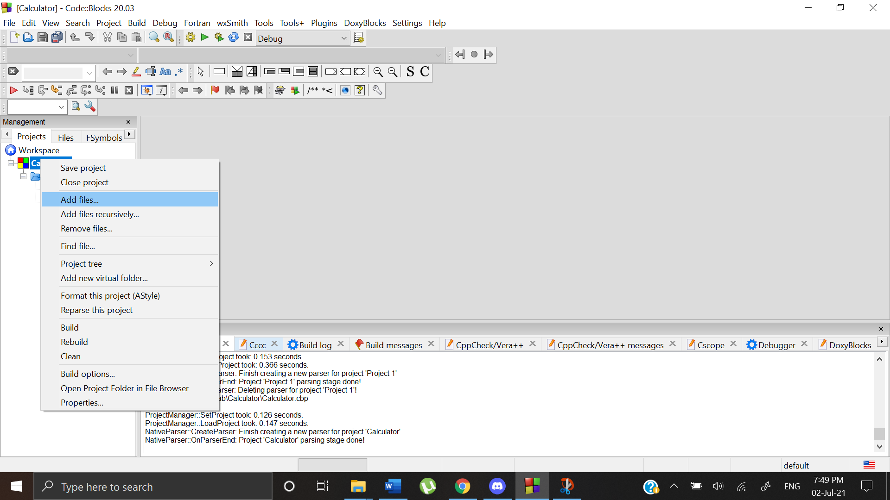 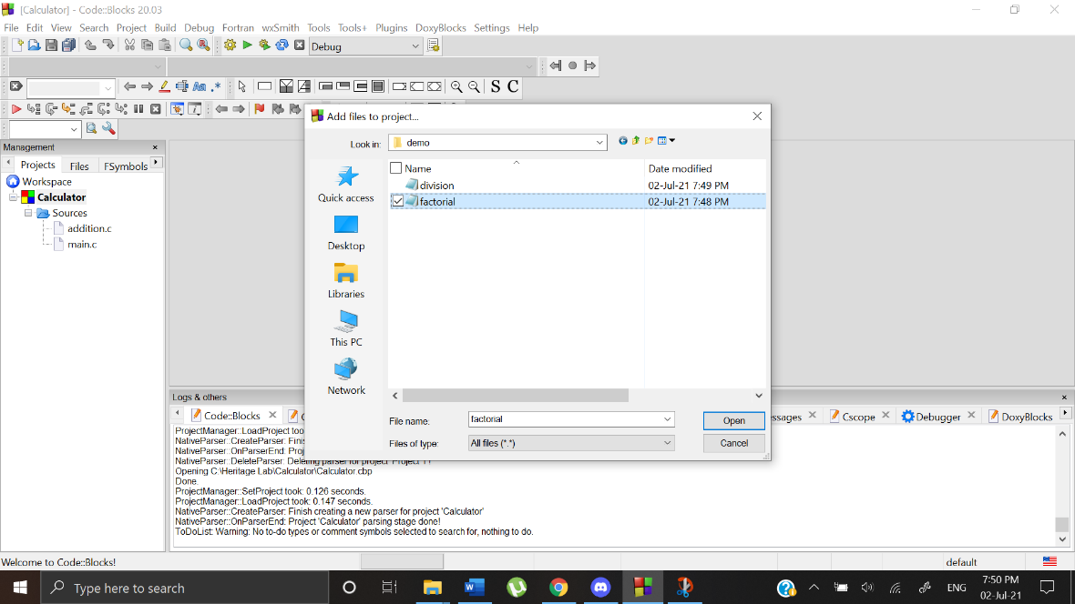

By adding files from multiple locations our workspace will look like this

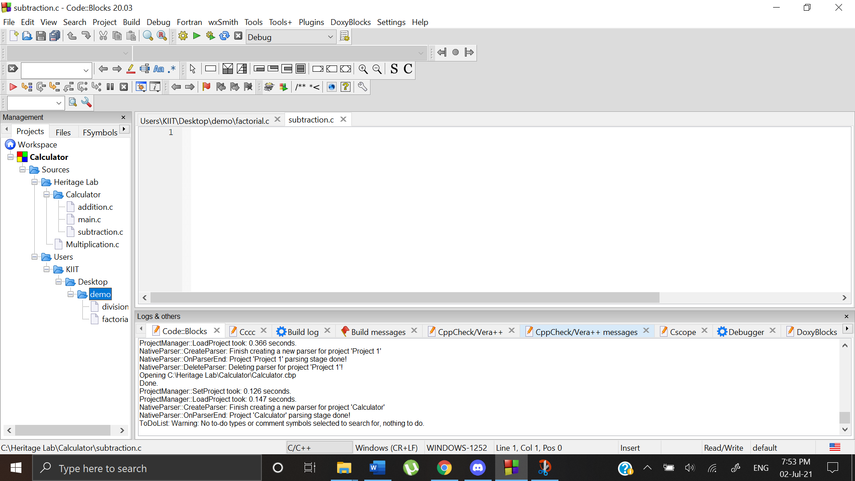

Output:

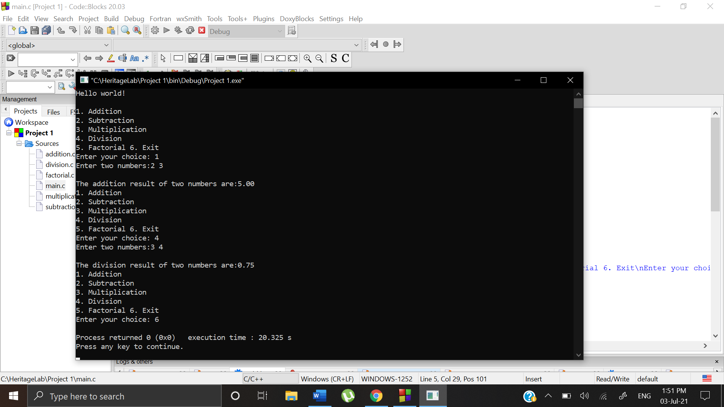

Assignment-2

We use the same steps in Assignment- 1 to create new project named SumOfFactorial. We write the main function. Now we need to import the functions from Calculator project.

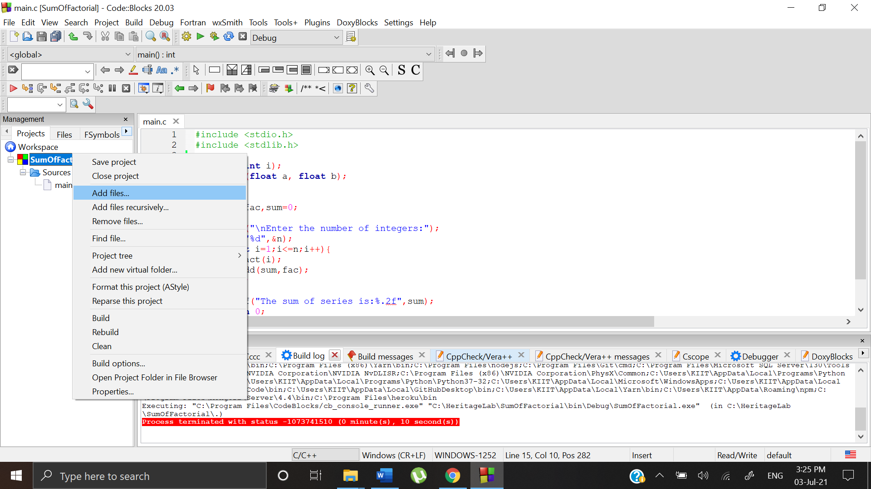 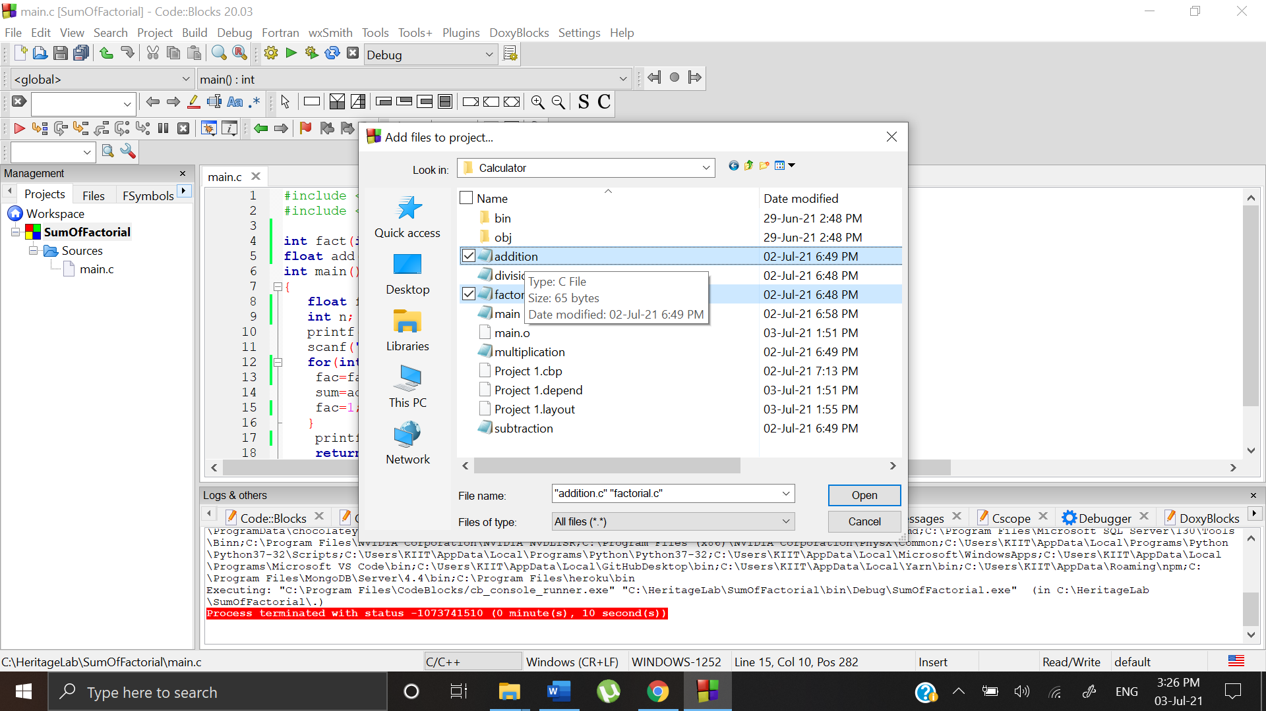

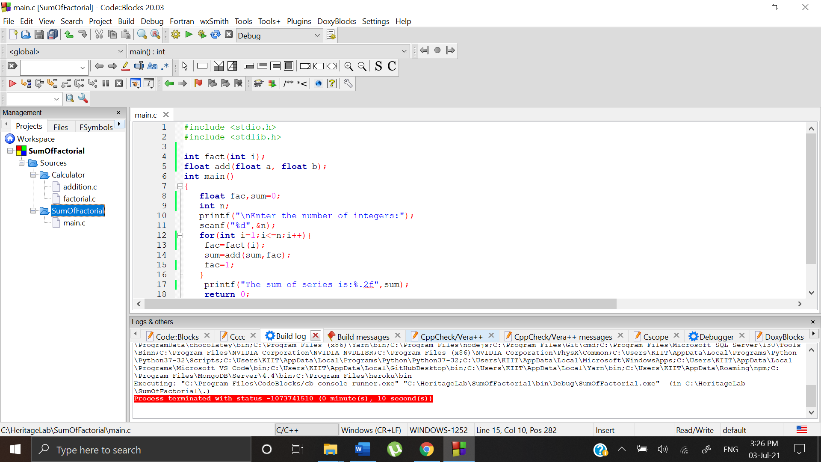

Now both the functions are imported. We need to make function declaration inside main.c of SumOfFactorial project and after that our code will run to fetch the desired results.

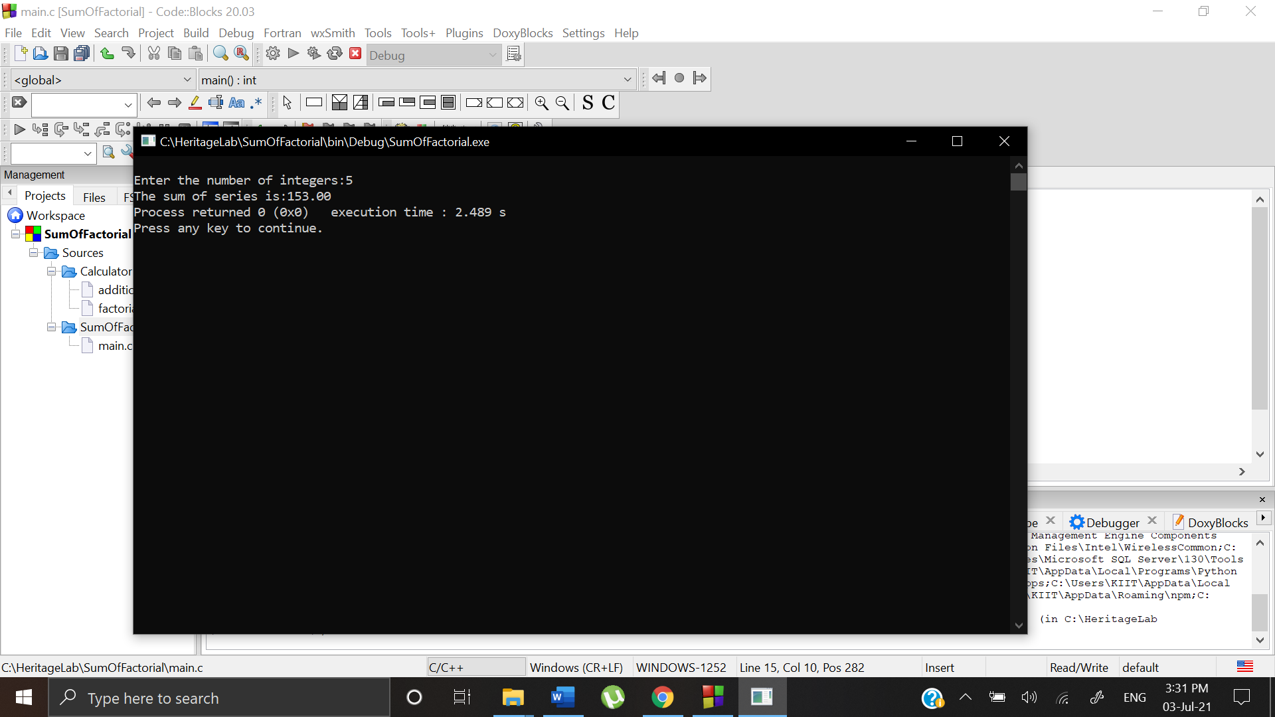

Debugging:

To find a bug we can set breakpoints to different lines of codes where we suspect the bug can occur. Then we can press f8 to start debugging. In this given code we are getting the output as INF which is not correct. The correct value must be a float value.

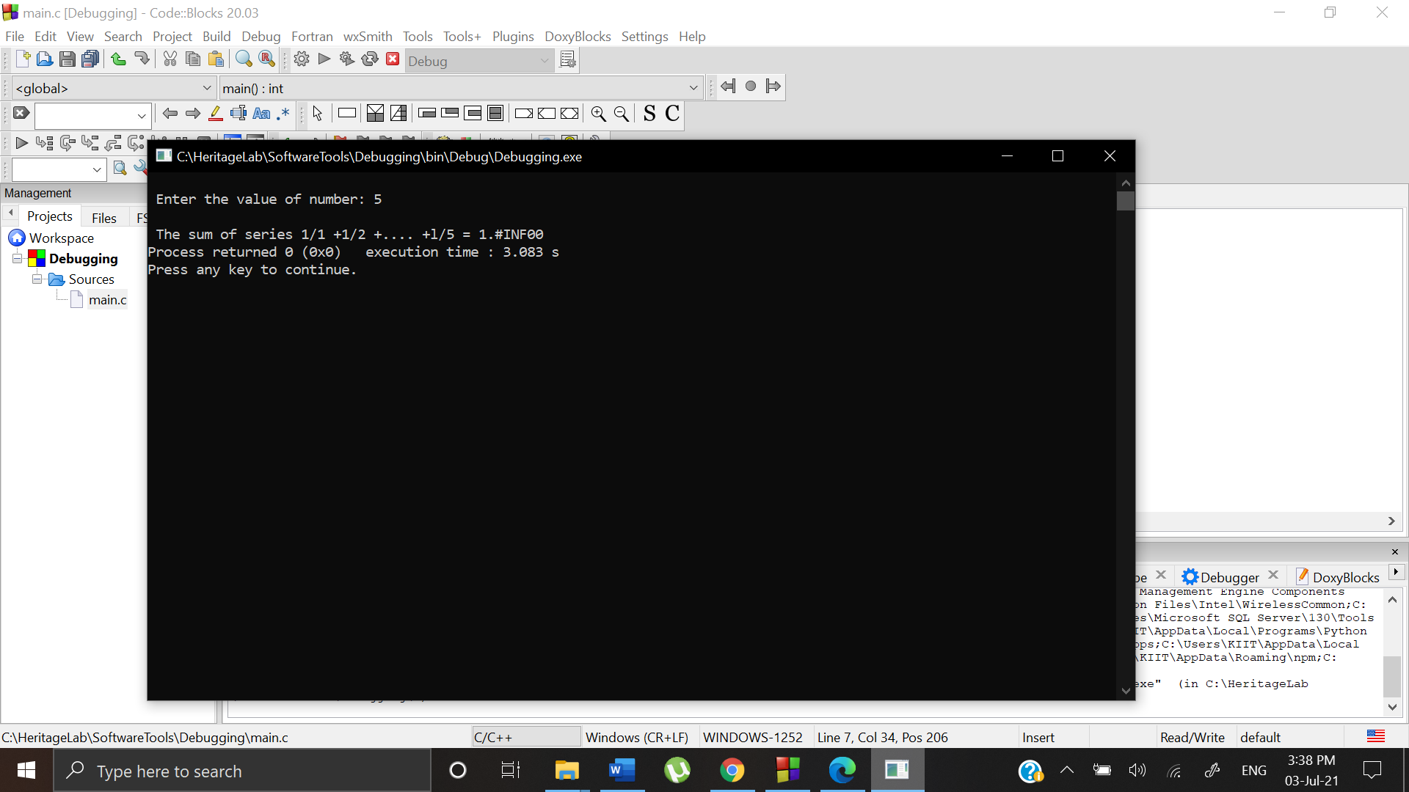

Assigning breakpoints by clicking along the line numbers.

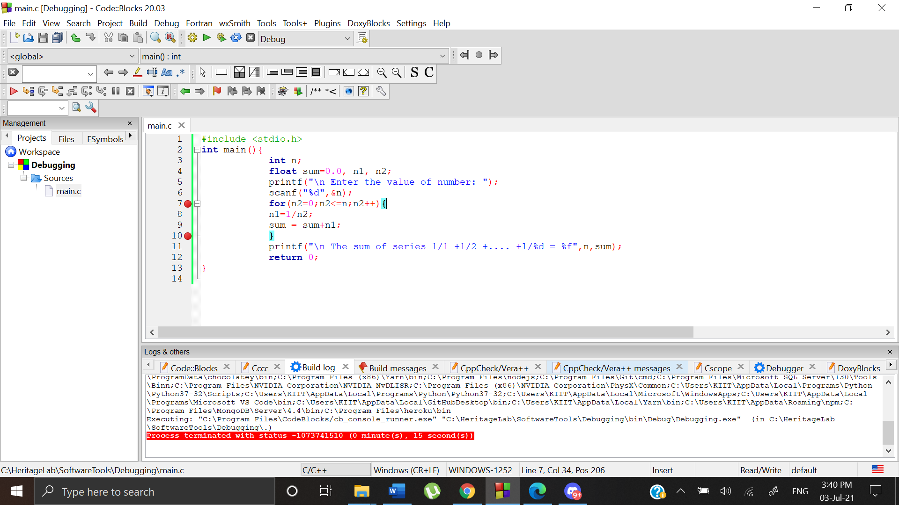

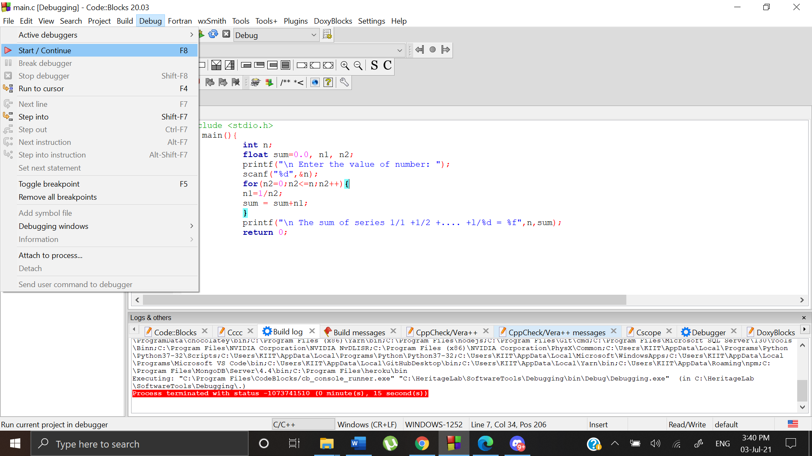 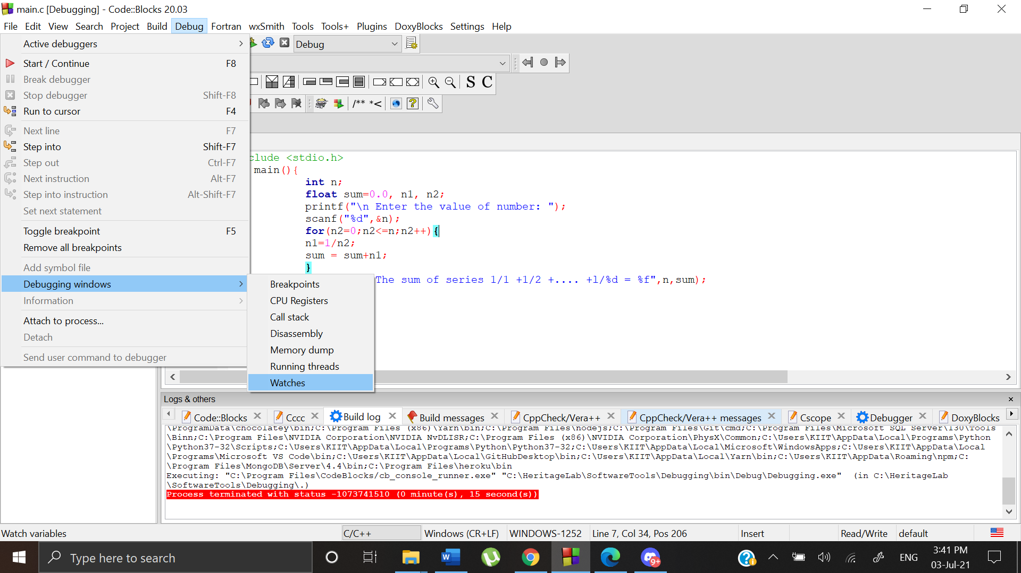

As we can see watch counter helps to keep variables in check while executing debugging

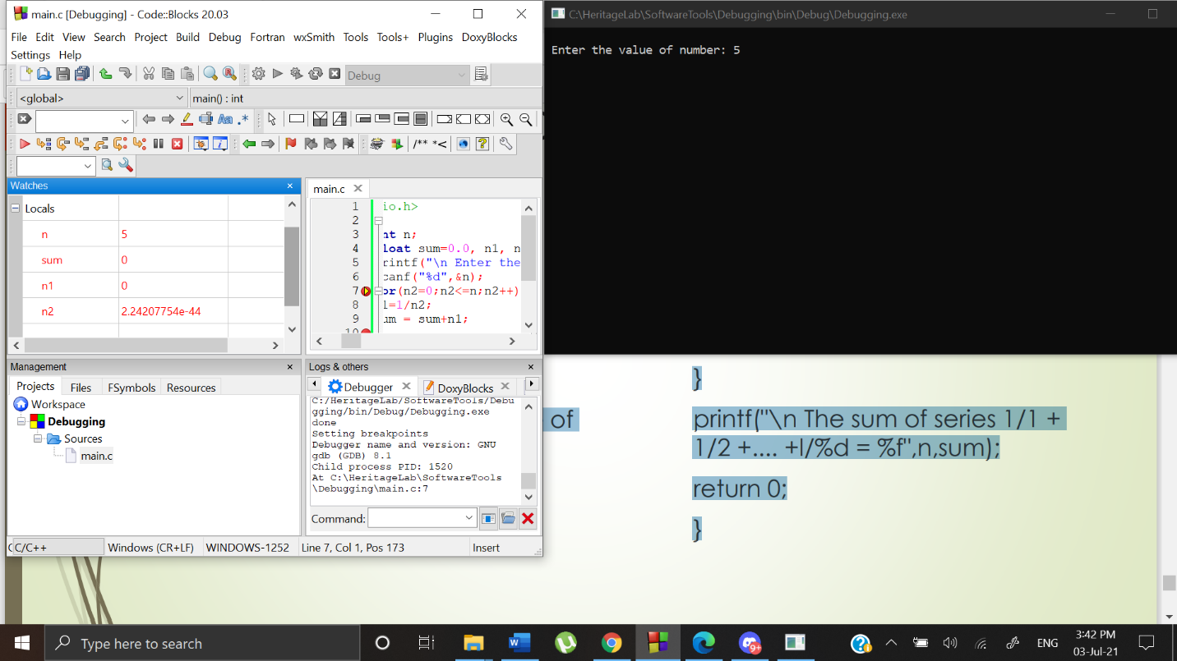

As we can see n1 becomes inf at first iteration which makes the whole program wrong.

